How to consent to receive your W2 electronically:
Step 1: Login to PASS
- On Home Screen select Payroll & Compensation Tile
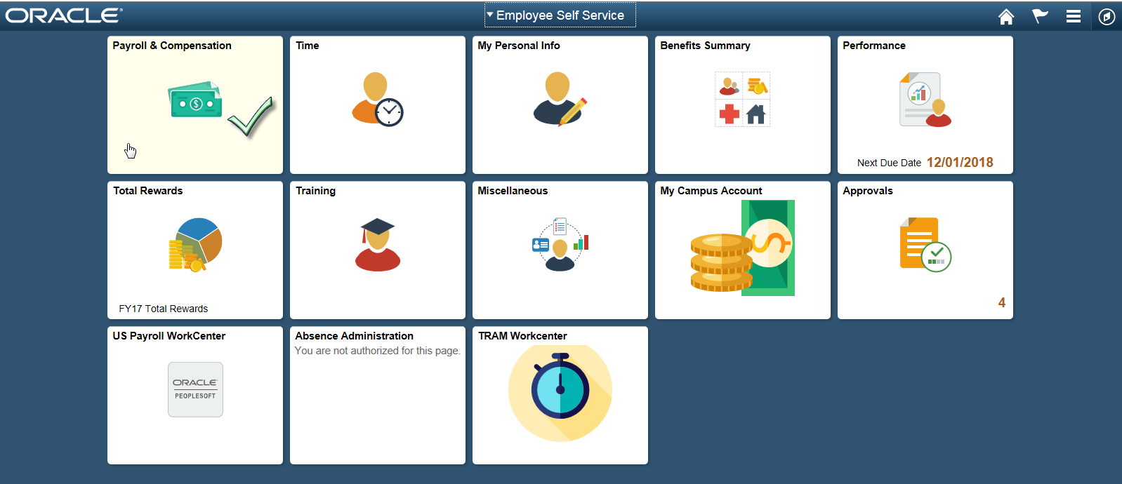
Step 2: View W-2/W-2c Consent
- Scroll down, on the left side select W-2/W-2c Consent
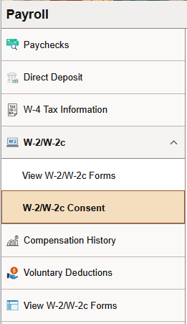

- Select and read the W-2/W-2c Consent
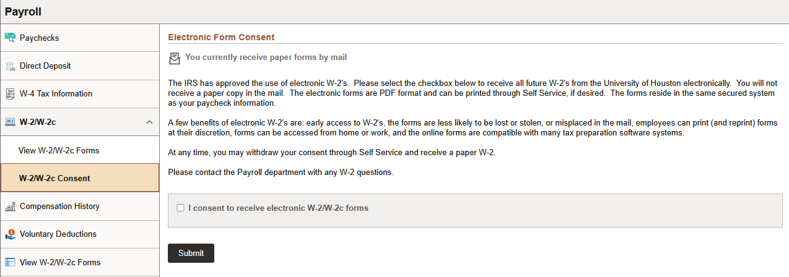
- Check box (I consent to receive W-2 or W-2c forms electronically)
- Click Submit Button, after you submit your consent you will receive the online confirmation
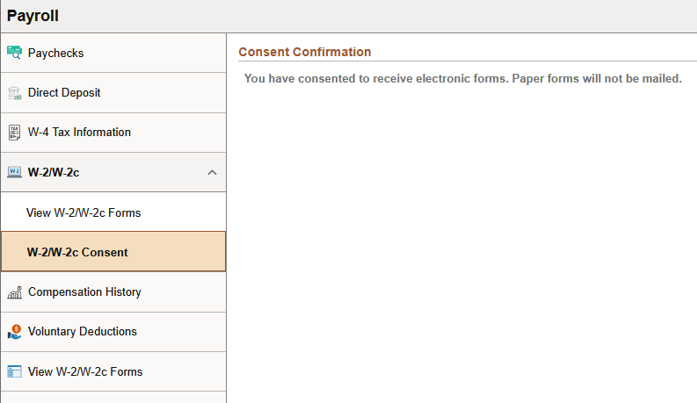
- In addition to the online confirmation an email confirmation will be sent to your email address on file.
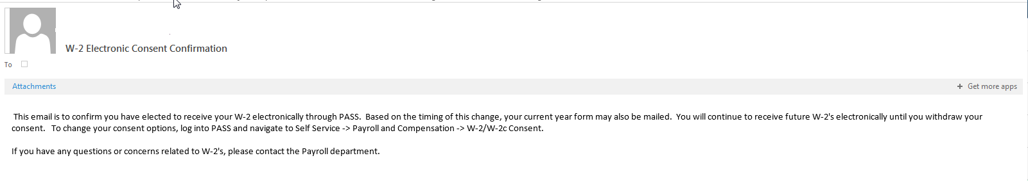
How to view and print your W-2/W-2c Forms:
Step 1: View W-2/W-2c Forms
- In your Payroll & Compensation Tile – select View W-2/W-2c Forms
- Select Year End Form hyperlink to open your W2
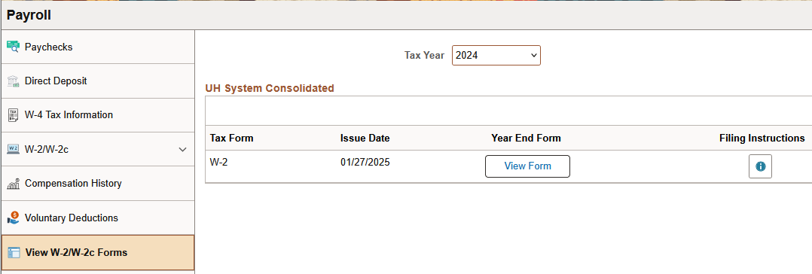
- You will be asked to Validate your information before the form will open.

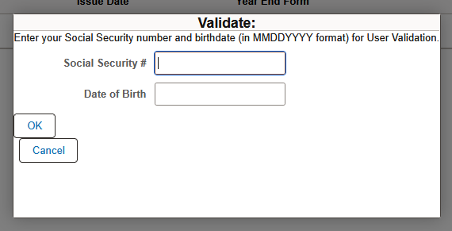

- Enter your Social Security Number & Date of Birth
- Click Ok
- W2 opens for review and/or printing in a pdf format

