How to create a requisition

Step 1: Go to Purchasing>Requisitions>Add/Update Requisitions

Step 2: You are on the Requisition Form page. Select Business Unit, then click on the Add button.

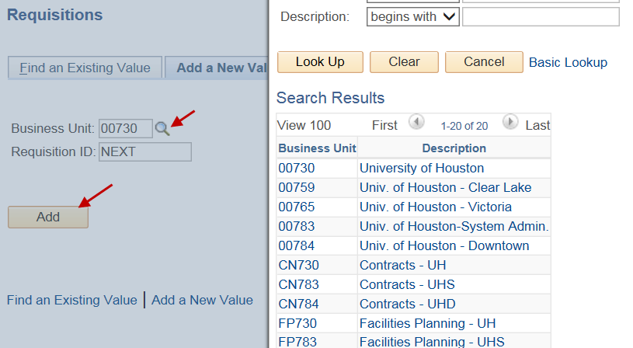

Please note:
If your requisition is FP730 or FP783, contact Facilities for instructions.
If your requisition is RC730, contact Division of Research for instructions.

Step 3: In the Header section, enter Requester’s Empl ID. If you do not know the Empl ID, click on the magnifying glass icon and find the value.

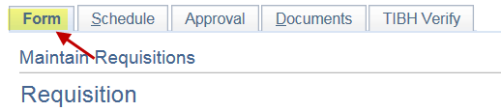
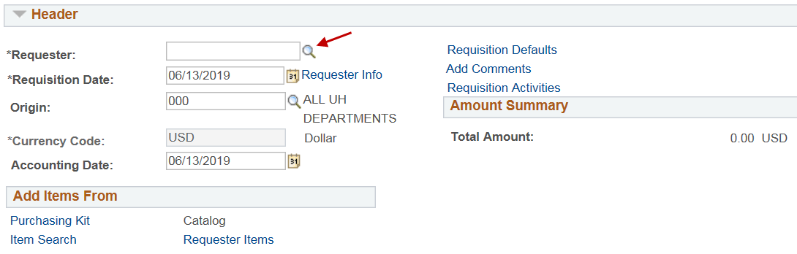

Step 4: In the Header section, click on “requisition Defaults”.
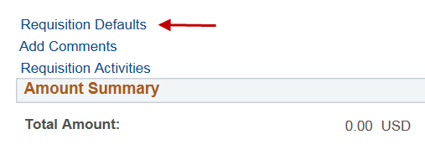
Step 5: The system will display the Requisition Defaults page.
- Make sure “Override” is selected in the Default Options section.
- In the line section, enter the Buyer name. Your department is assigned to a particular buyer. Go to the Purchasing website (http://www.uh.edu/office-of-finance/purchasing/faculty-staff-resources/buyer-designations) to find out the buyer assigned to you.
  - For RC730/783 select DOR buyers, contact DOR.
  - For FP730/783 select Facilities buyers, contact Facilities.
- In the line section, enter the vendor ID ad verify vendor location (payable address).
- In the schedule section, enter the due date, and make sure “Amount” is shown in the Distribute By field. The due date should be prior to the quote expiration date.
- Click on .

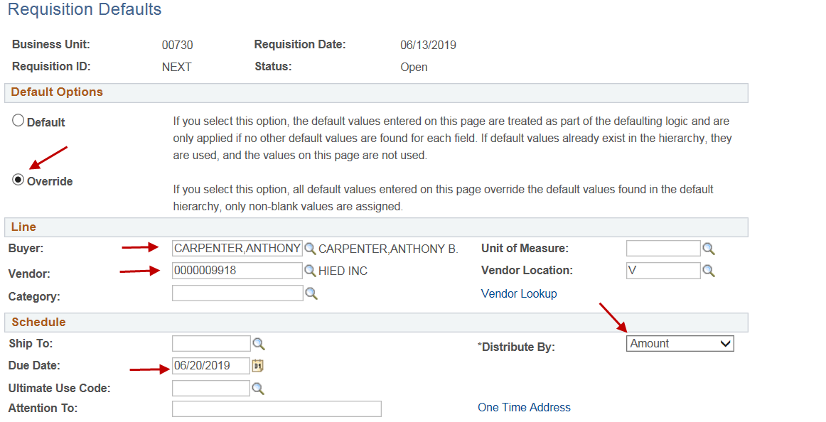

Step 6: You are back to the Requisition Form page. In the line section, enter the following:
- Description (up to 254 characters).
- Quantity of your order.
- UOM - click on the magnifying glass icon, and select applicable measure.
- Category – click on the magnifying glass icon, and select applicable category.
- Price.
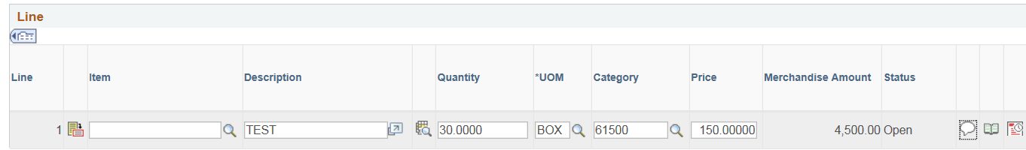
Step 7: In the Line section of the Requisition Form page, click on 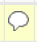 .
- Enter comments including purpose/benefit and other information that Purchasing may need in order to process your order (e.g., UH contact name and phone number, etc.).
- Check mark “Send to Vendor”.
- Click on .

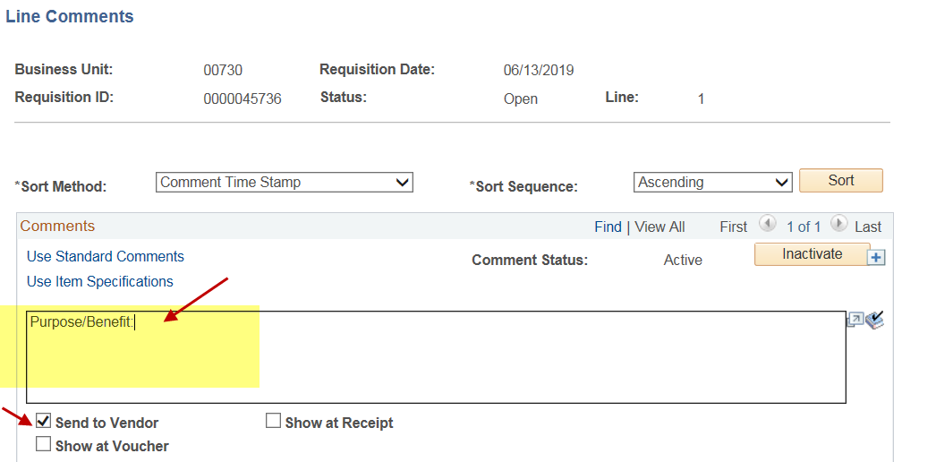

Step 8: You are back to the Form page. If you are using multiple cost centers, click on in the Line section to create additional lines. For example, you have one state cost center and two local cost centers to pay for the requisition, you would create three lines here.

Step 9: Go to the Requisition Schedule Page, enter the following:
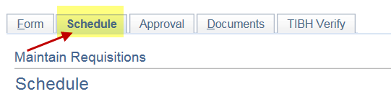
- “Ship To” location. You can click on the magnifying glass icon and select the value.

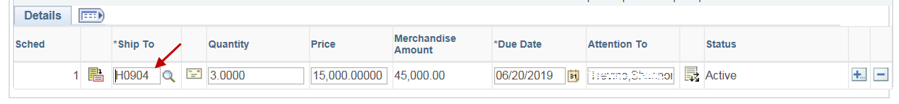

- Click on 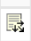. The system will display the Distribution page. Enter account and cost center. You may use speedtype and may enter multiple lines. Note: This is a distribution line level. Do not enter local and state cost centers at this level. If you are using both state and local cost center, you would need to create separate lines (not distribution lines). Go back to Step 8.

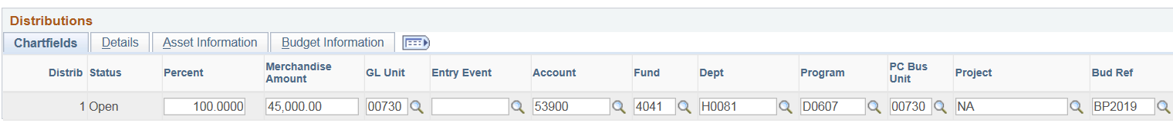

- Go to the details tub, and enter location, and click on.
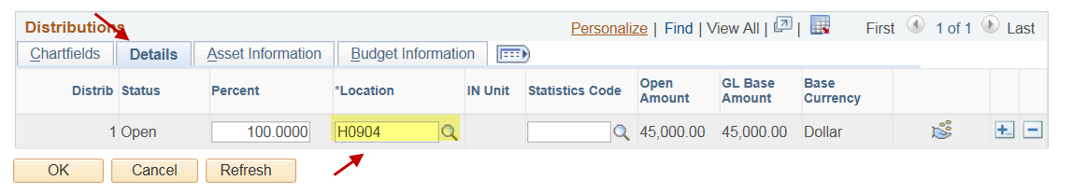

Step 9: Go to the Requisition Documents page. Click on “Print Requisition Coversheet” and review the information on the page.
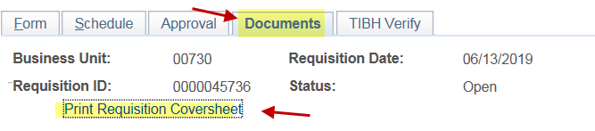

Step10: In the requisition Documents page, click on “Add New Document” to upload the required documents.

Step 11: If your requisition is CN730 or CN783, you will need to complete the Contract page. See “UHS Contracts Page Instructions for Revenue & Expense Contracts” (http://www.uh.edu/office-of-finance/purchasing/Purchasing%20Training) for the instruction.
If your requisition is not for CN730 or CN783, go to Step 12.

Step 12: Go back to the Requisition Form page, and budget check the requisition.
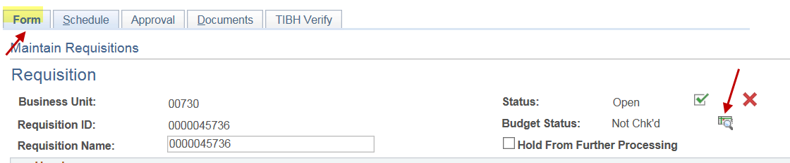
Make sure that the requisition has a valid budget check status.
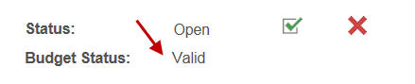
Step 13: Go to the Requisition Approval page.
If federal funds are used within 100 days of the expiration date, route the requisition through OCG. Otherwise, route the requisition directly to Purchasing.
Then, select “Approve” and click on the apply button.
