GENERAL INFORMATION
The University of Houston System is required to comply with state contract reporting requirements. To help ensure compliance, the UHS Contracts Page will be used as a single point of data entry for all contract information that the University is required to report to the Legislative Budget Board (LBB) either by statute or the General Appropriations Act (GAA). Purchasing staff will use the data collected from this page to report contracts to the LBB.
Effective 06/01/2020, sponsored research consultant agreements and sub-recipient agreements using fund 5 (except for fund 5999) must be entered into the UHS Contracts Page via RC730 requisition. The following table shows the different types of sponsored research purchases and each of its requirements.
Procurement Vehicle | Description | Requisition Required | UHS Contracts Page Required | Requisition Business Unit
Consultant Agreement | Person hired in a professional capacity to provide specific expertise in the technical area of the project for a specified period of time under a sponsored agreement. | Yes | Yes | RC730
Sub-recipient Agreement | Under 2 CFR 200.92, the Uniform Guidance, Sub-award means an award provided by a pass-through entity to a sub-recipient for the sub-recipient to carry out part of a Federal award received by the pass-through entity. | Yes  (created by DOR) | Yes | RC730
All Other Services Agreements (except for consultants or sub-recipients) | Services are works or duties provided to the University, and are provided by business organizations or individuals. Services may be standalone (one time) or repetitive or ongoing. | Yes | Yes | CN730  CN783  RC730 (If paid on grant cost center)
Purchase Order (i.e., no terms and conditions) | Purchase of goods processed through purchasing department. Goods are tangible, physical items. Goods are standalone purchases – once it is purchased, the relationship ends. | Yes | No | 00730  00783
Notes:
- Requisitions for Sub-recipient Agreements will be created by DOR. All other requisitions will be created by UH departments.
- The partially executed agreement should be uploaded to the requisition to be routed to OCG for review and execution. OCG will upload the fully executed signed agreement to the UHS contract page
- A copy of the fully executed signed agreement must be uploaded to the UHS contracts page, along with the Contract Coversheet, Recommendation for Award, Sole Source Justification form (if applicable), and any bids/quotes obtained by the originating department.

The University is required to report contracts to the LBB as follows:

TYPE OF CONTRACT | VALUE THRESHOLD | REPORTING TIMEFRAME | LOCATION
Professional Services (except for physician or optometric services) | > $14,000 | 10 days after award | 2254.006, 2254.0301  Government Code
Construction | > $14,000 | 10 days after award | 2166.2551  Government Code
Major Information Systems | > $1,000,000 | 10 days after award | 2054.008  Government Code
All | > $50,000 | 30 days after award | GAA Article IX, Sec 7.04
Non-Competitive/Sole Source | > $1,000,000 | Prior to first payment, but not later than 30 days after award | GAA Article IX, Sec 7.12
Emergency | > $1,000,000 | 48 hours after payment | GAA Article IX, Sec 7.12
All | > $10,000,000 | Prior to first payment, but not later than 30 days after award | GAA Article IX, Sec 7.12
CONTRACT AMENDMENTS
For reporting purposes, contract amendments will be treated as separate contract entries. Departments will need to create a new contract in the system to record the amendment and link it to the requisition.

See example below:

Original Contract (executed 8/22/2019)
Contract ID: K-19-12345
Total Amount: $100,000
Term: 9/1/2019 – 8/31/2022

Amendment 1 (executed 7/15/2022)
Contract ID: K-19-12345-1
Total Amount (original + amendment): $175,000
Term (original + amendment): 9/1/2019 – 8/31/2024

FY20 - Department creates requisition #1 and enters contract K-19-12345
FY21 - Department creates requisition #2 and links it to contract K-19-12345
FY22 - Department creates requisition #3 and links it to contract K-19-12345
FY23 - Department creates requisition #4 and enters amendment K-19-12345-1
FY24 - Department creates requisition #5 and links it to amendment K-19-12345-1

INSTRUCTIONS
Step 1: Create requisition by following the “How to create a requisition” training located at http://www.uh.edu/office-of-finance/purchasing/Purchasing%20Training/
Step 2: Click on the “Contract” tab. Expense contracts can be created and/or added (if contract was previously created) from this page.
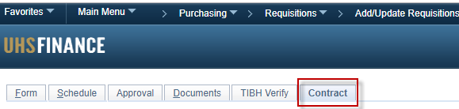
- Add an existing contract to the requisition by going to the “Add Existing Contract” section below. Note that you can only add an existing contract if someone already created that contract.
- Create a new contract by going to Step 3.
Add Existing Contract
- Click the search icon. The Look Up page is displayed.
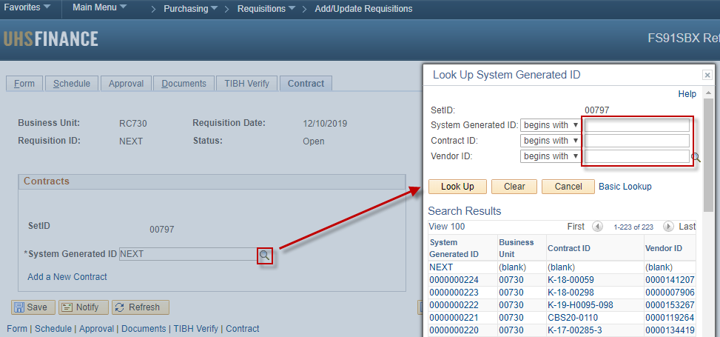
- You can search for contracts by:
System Generated ID | This is a 6-digit unique number that is automatically generated by the system once a contract is saved.
Contract ID | K Number assigned by OCA or department assigned number if no K number available.
Vendor ID | Unique number assigned to vendors that receive non-payroll payments from UH System.
- Once contract is found, select to add and click save.
- You can view the selected contract by clicking on the “View Contract” link.
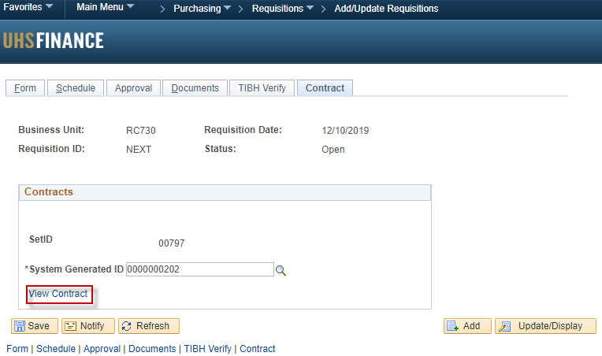
Step 3: Click the “Add New Contract” link. Do not enter anything on the “System Generated ID” field.
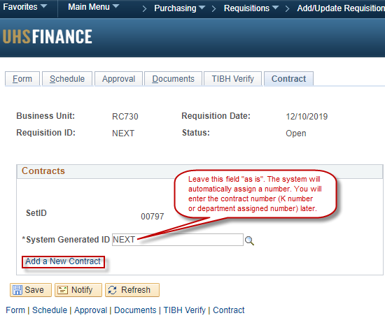
Step 4: Fill out all the applicable fields. Use the following definitions to determine what information needs to be entered.
Contract ID | The Contract ID (K Number) assigned by the Office of Contract Administration (OCA). Use department assigned contract number only if there is not a K number available.
Amended | Only select this box if contract has been amended.
Subject | The subject provides a description of the contract’s general purpose. Example: Data analysis and research study
Competitively Procured | This field is used to differentiate between competitively and non-competitively procured contracts.
Revenue Generating | Do not check this box. This is only used for revenue contracts
Agency Approval Date | The Agency Approval Date specifies the date on which final approval was given to proceed with contracting for the purchase or sale of goods and/or services. The Agency Approval Date cannot be later than the Solicitation Post Date or the Award Date.  Please use one of the options below:  - Formal bid - date formal solicitation was posted to the ESBD.  - Informal bid - dates bids were requested from vendors.  - Sole source or emergency - date Purchasing signed the sole source justification form or approved the emergency purchase.
Award Date | The Award Date is the date the University executed (signed) the contract.
Expiration Date | The Expiration Date is the date when the contract will end pursuant to its terms and conditions.
Vendor ID | Unique number assigned to vendors that receive non-payroll payments from UH System.
Address | Use vendor address listed on contract. If address is not found use the same address as PO.
Current Value | The Current Contract Value includes the value of the contract, any amendments, and any exercised extensions or renewals.
Maximum Value | The Maximum Contract Value field should include the value of the contract, amendments, and all potential extensions or renewals that have not been exercised. The total amount both currently and potentially obligated.
Solicitation Posting Date | Enter date solicitation was posted for public bidding OR leave blank if not applicable. This is normally found on the first page of the solicitation.
Number of Bids Received | The # of Bids Received is used to indicate the number of bids that the University received in response to the formal/informal solicitation. Enter 1 if state contract, cooperative contract, or sole source purchase.
Solicitation Number | Enter solicitation number or NA if not applicable.
Step 5: Attach contract files.
Step 6: Save & Submit.

